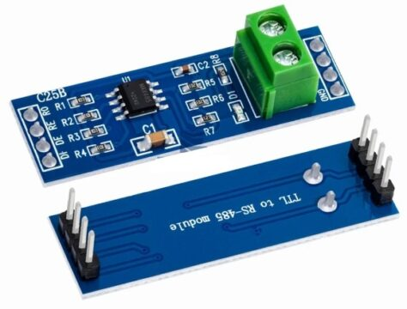

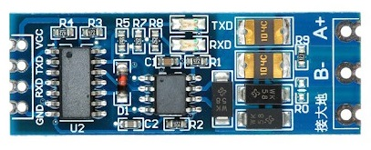

MODBUS RS485

Transmitter

#define TXD2 17 // UART2 TX pin
#define RXD2 16 // UART2 RX pin (for loopback tests)
#define DE_RE 4 // Direction control pin

void setup() {
Serial.begin(115200);
Serial2.begin(9600, SERIAL_8N1, RXD2, TXD2);
pinMode(DE_RE, OUTPUT);
digitalWrite(DE_RE, HIGH); // Enable transmit
}

void loop() {
digitalWrite(DE_RE, HIGH); // Enable transmit
Serial2.write("Hello from ESP32!\n");
delay(1000);
digitalWrite(DE_RE, LOW); // Set to receive after transmit
delay(1000);
}

Receiver

#define TXD2 17
#define RXD2 16
#define DE_RE 4

void setup() {
Serial.begin(115200);
Serial2.begin(9600, SERIAL_8N1, RXD2, TXD2);
pinMode(DE_RE, OUTPUT);
digitalWrite(DE_RE, LOW); // Enable receive
}

void loop() {
if (Serial2.available()) {
char c = Serial2.read();
Serial.write(c);
}
}

Hardware Connections
- TX (transmit) pin of ESP32 → DI (Data In) pin on MAX485.
- RX (receive) pin of ESP32 → RO (Receive Out) pin on MAX485.
- ESP32 GPIO, e.g., GPIO 16 → DE (Driver Enable) and RE (Receiver Enable) pins tied together on MAX485.
- VCC of MAX485 → 5V (or 3.3V if module supports it) power supply.
- GND of MAX485 → ESP32 GND.
- A/B differential pair of MAX485 → RS485 bus wires (A/B twisted pair).
The DE/RE pin is set HIGH for transmit mode and LOW for receive mode. The MAX485 VCC should match its logic compatibility—use level shifting if you must mix 5V MAX485 with 3.3V ESP32.​

ESP32 RS485 Transmitter Example (Arduino Framework)

Typical Connection Table
ESP32 Pin | MAX485 Pin | Purpose
TX (GPIO 17) | DI | UART data out
RX (GPIO 16) | RO | UART data in
GPIO 4 | DE & RE tied | Direction control (TX/RX mode)
GND | GND | Common ground
3.3V or 5V | VCC | Power (see module requirement)
-- | A/B | RS485 differential bus wires
These connections configure the ESP32 and MAX485 module for simple half-duplex RS485 serial communication.​

ESP32 Transmitter Side
- TX (UART, e.g. GPIO 16 on ESP32) → DI (MAX485)
- RX (UART, e.g. GPIO 17 on ESP32, optional for loopback) → RO (MAX485)
- GPIO control pin (e.g., GPIO 4) → DE (MAX485), RE (MAX485) (tie both pins together)
- GND (ESP32) → GND (MAX485)
- 3.3V or 5V (matching MAX485 module requirements) → VCC (MAX485)
- A/B RS485 output → A/B bus wires

ESP32 Receiver Side
- TX (UART, e.g. GPIO 16) → DI (MAX485, optional)
- RX (UART, e.g. GPIO 17) → RO (MAX485)
- GPIO control pin (e.g., GPIO 4) → DE (MAX485), RE (MAX485) (tie both pins together)
- GND → GND
- 3.3V/5V → VCC
- A/B RS485 input → A/B bus wires

Bus Connections
- A (Transmitter MAX485) → A (Receiver MAX485)
- B (Transmitter MAX485) → B (Receiver MAX485)
- Both ends of the RS485 bus (A/B) should have 120Ω termination resistors.

Key Wiring Table
ESP32 (Transmitter) | MAX485 | RS485 Bus | MAX485 | ESP32 (Receiver)
TX (GPIO 16) | DI | A | A | RO (GPIO 17)
RX (GPIO 17, opt.) | RO (opt.) | B | B | DI (GPIO 16, opt.)
GPIO 4 | DE + RE |  | DE + RE | GPIO 4
GND | GND |  | GND | GND
3.3V or 5V | VCC |  | VCC | 3.3V or 5V
This setup enables RS485 data transmission and reception between two ESP32 boards, with clear UART and control connections. Always verify voltage compatibility for each module (most MAX485 modules require 5V, so level shifters may be necessary if ESP32 is operating at 3.3V).​
For schematic visuals, sites like ESP32IO and PCBONLINE provide block diagrams that follow this wiring method.​

ESP32 Transmitter Side
- TX (UART, e.g. GPIO 16 on ESP32) → DI (MAX485)
- RX (UART, e.g. GPIO 17 on ESP32, optional for loopback) → RO (MAX485)
- GPIO control pin (e.g., GPIO 4) → DE (MAX485), RE (MAX485) (tie both pins together)
- GND (ESP32) → GND (MAX485)
- 3.3V or 5V (matching MAX485 module requirements) → VCC (MAX485)
- A/B RS485 output → A/B bus wires

ESP32 Receiver Side
- TX (UART, e.g. GPIO 16) → DI (MAX485, optional)
- RX (UART, e.g. GPIO 17) → RO (MAX485)
- GPIO control pin (e.g., GPIO 4) → DE (MAX485), RE (MAX485) (tie both pins together)
- GND → GND
- 3.3V/5V → VCC
- A/B RS485 input → A/B bus wires

Bus Connections
- A (Transmitter MAX485) → A (Receiver MAX485)
- B (Transmitter MAX485) → B (Receiver MAX485)
- Both ends of the RS485 bus (A/B) should have 120Ω termination resistors.

